Website Proposal WEDE
st10508988
Lethabo Thokozane Sithebe
2026
Contents
Proposal 1 (Le Petit Coffee) 2
1. Organisational background: 2
2.Website Objectives: 3
3.Website features and functionality: 3
4.Design and branding: 4
5. Hosting and technologies: 4
6.Budget 4
7. Timeline: 5
Proposal 2 (ShapBraai Shisanyama) 6
1. Organisational background: 6
2. Website Goals: 7
3. Website Features and Functionality: 7
4. Branding and Design: 7
5. Budget: 8
6. Timeline: 8
7. Hosting and Technologies: 9
Reference list: 10

Proposal 1 (Le Petit Coffee)

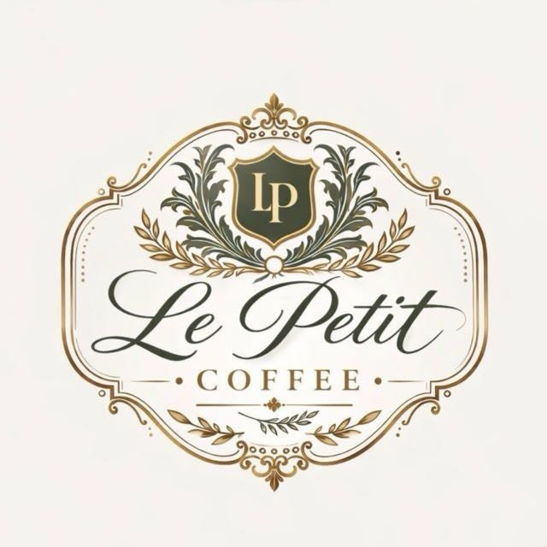
1. Organisational background:
- Le Petit Coffee is a small coffee shop that’s located in Oakdene, Johannesburg, South Africa.
- The café serves:
- Freshly brewed coffee
- Teas
- Hot chocolate
- A variety of pastries
- Sandwiches
- Light meals
- The café provides these in a welcoming environment.
- It mainly relies on:
- Walk-in customers
- Social media, such as Instagram (@le.petit.coffee), to promote their business.
- The main mission for the café is:
- To provide high-quality coffee
- Delicious food
- Excellent customer service
- In a cosy and welcoming setting
- Their vision is:
- To establish an online presence
- Provide exceptional client experiences
- To become one of Johannesburg South’s most favoured coffee shops.
- The target demographic includes:
- Students
- Working professionals
- Families
- Tourists
- Locals searching for good coffee, food, and a cosy space to connect or work.

2.Website Objectives:
- The main objective is to create a useful and aesthetically pleasing website that raises the cafe's internet profile.
- The website will:
- Encourage users to visit the café
- Allow users to get in touch with the company with questions
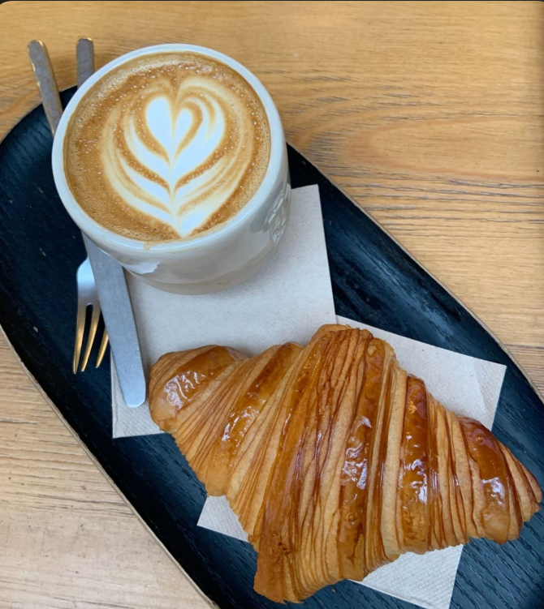
- Offer details on the menu
- Provide the location
- Provide hours of operation
- Provide information about specials

3.Website features and functionality:
- The website will have:
- Home
- About us
- Menu
- Gallery
- Special offers
- Contact us
- The website will include:
- A Google Maps location
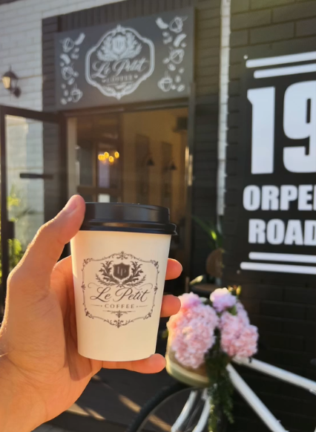
- Social media connections
- An inquiry form
- A responsive design that functions effectively on desktop and mobile devices.
- Consumers will be able to:
- Quickly locate the café contact details
- Peruse menu items

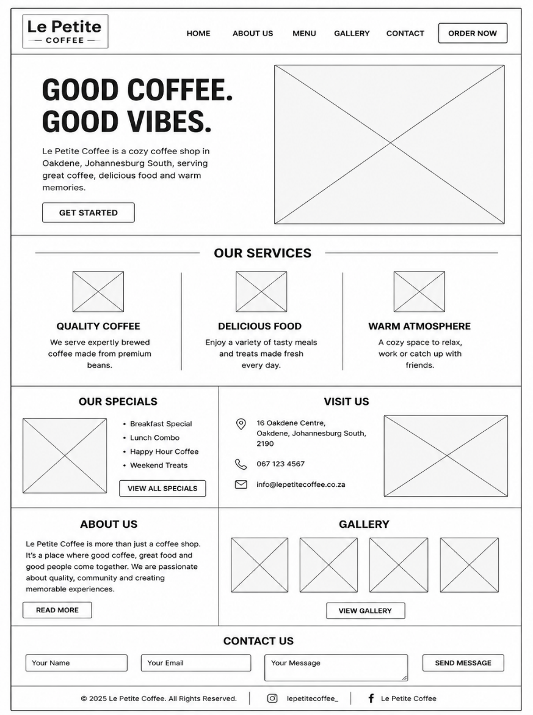

4.Design and branding:
- Warm hues like:
- Brown
- Cream
- White
- Dark green
- These colours will be used on the website to create a cosy coffee shop ambience.
- Sanskrit Text will be used for the body
- Aptos Display for the heading.
- The design will include:
- Clear call-to-action buttons
- A hero banner with highlighted items
- A straightforward navigation menu
- Excellent photos

5. Hosting and technologies:
- Suggested domain name: www.lepetit.coffee.co.za
- A reputable hosting company with SSL security will host the website.
- To guarantee a responsive and user-friendly design, development will make use of:
- HTML
- CSS
- JavaScript

6.Budget
Website development | R2500
Domain registration | R200
Web hosting | R550
Testing | R1500
Ongoing maintenance | R3000
Total: | R7750

Timeline:
Activity | Duration | Planned dates
Research | 23 July-31 July | 9 days
Planning | 1 August-7 August | 1 week
Website design | 8 August-14 August | 1 week
Website Development (HTML) | 1 August-14 August | 2 weeks
Website development (CSS and JavaScript) | 15 August-18 September | 5 weeks
Testing | 19 September-10 October | 3 weeks
Domain registration and hosting | October-November 2026 | 2-3 weeks

Proposal 2 (ShapBraai Shisanyama)

1. Organisational background:

- ShapBraai Shisanyama is a South African restraint that specialises in traditional braai meals and provides customers with an authentic Shisanyama experience.
- The business is known through its social media presence and attracts customers looking for:
- Quality grilled meat
- Good food
- A vibrant atmosphere
- A dedicated website would strengthen its online presence and make it easier for customers to access information and services.
- Their mission is:
- To offer exceptional customer service
- Delectable, premium braai dishes
- In a friendly setting
- Their vision is;
- To become one of the top Shisanyama eateries in South Africa
- By providing exceptional cuisine and dining experiences
- The target demographic includes:
- Family
- Young individuals
- Working professionals
- Tourists
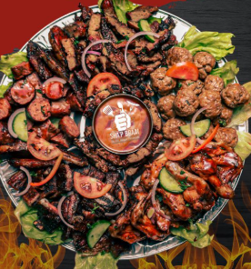
- Anyone who appreciates traditional South African braai food.

2. Website Goals:
- The website's objectives are to:
- Raise brand recognition
- Showcase the menu
- Advertise weekly events and discounts
- Let users reserve tables
- Generate enquiries
- Enhance customer involvement

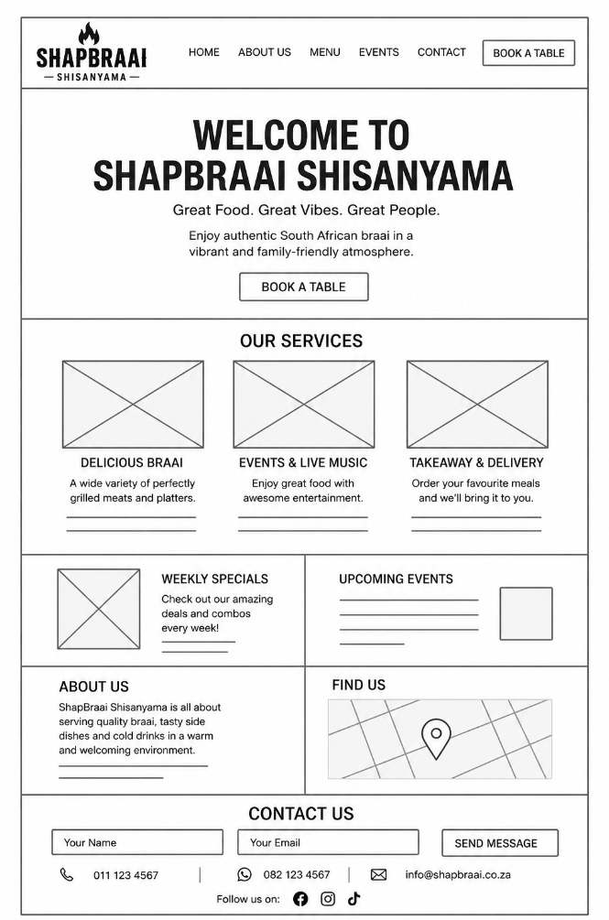

3. Website Features and Functionality:
- The website will have:
- Home
- About us
- Menu
- Gallery
- Events
- Book a table
- Contact us
- The website will include:
- An online reservation form
- Social media links
- Google Maps integration
- A WhatsApp contact button
- Customer evaluations
- A mobile- and desktop-responsive design

4. Branding and Design:
- Colours:
- Black
- Red
- Orange
- Charcoal
- These colours will be used on the website to evoke the cosiness of a typical braai.
- Poppins will be used for headers
- Beb’s Neue for headers
- The homepage will include:
- A hero banner
- Highlighted dishes
- Client endorsements
- Easy navigation \

5. Budget:
Website development | R2500
Domain registration | R200
Web hosting | R550
Testing | R1500
Ongoing maintenance | R3000
Total: | R7750

6. Timeline:
Activity | Duration | Planned dates
Research | 23 July-31 July | 9 days
Planning | 1 August-7 August | 1 week
Website design | 8 August-14 August | 1 week
Website Development (HTML) | 1 August-14 August | 2 weeks
Website development (CSS and JavaScript) | 15 August-18 September | 5 weeks
Testing | 19 September-10 October | 3 weeks
Domain registration and hosting | October-November 2026 | 2-3 weeks

7. Hosting and Technologies:
- Preferred domain name: www.shapbraai.co.za
- Will be hosted with secured SSL protection
- The use of:
- HTML
- CSS
- JavaScript

Reference list:
Le Petit Coffee Shop, 2026. @le.petit.coffee, Instagram. [online] Available at: https://www.instagram.com/le.petit.coffee/?hl=en. (Accessed 29 July 2026)
Le Petit Coffee Shop, 2026. Le Petit Coffee Shop, Facebook. [online] Available at: https://www.facebook.com/LePetitCoffeeShop/. (Accessed 29 July 2026)
ShapBraai, 2026. ShapBraai & Pizzeria, Facebook. [online] Available at: Sharp Braai | Johannesburg | Facebook. (Accessed 30 July 2026)
ShapBraai, 22026. @shapbraai, Instagram. [online] Available at: https://www.instagram.com/shapbraai/. (Accessed 30 July 2026)

